Session 2 - 1

import java.io.*;
import java.util.*;

public class Solution {

public static String twoStrings(String s1, String s2) {
// Create a set to store unique characters of s1
Set<Character> charsInS1 = new HashSet<>();

// Add all characters of s1 to the set
for (char c : s1.toCharArray()) {
charsInS1.add(c);
}

// Check if any character in s2 exists in the set
for (char c : s2.toCharArray()) {
if (charsInS1.contains(c)) {
return "YES";
}
}

// No common characters found
return "NO";
}

public static void main(String[] args) throws IOException {
BufferedReader bufferedReader = new BufferedReader(new InputStreamReader(System.in));

// Read number of test cases
int p = Integer.parseInt(bufferedReader.readLine().trim());

for (int i = 0; i < p; i++) {
String s1 = bufferedReader.readLine();
String s2 = bufferedReader.readLine();

String result = twoStrings(s1, s2);
System.out.println(result);
}

bufferedReader.close();
}
}

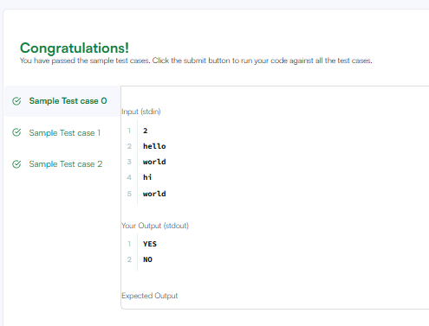

Session 2 -2

public class Solution {
public boolean rotateString(String s, String goal) {
// If lengths are different, s can never become goal
if (s.length() != goal.length()) {
return false;
}

// Concatenate s with itself
String doubledS = s + s;

// Check if goal is a substring of doubledS
return doubledS.contains(goal);
}
}
